CEN 4010 Principles of Software Engineering Spring 2021

Florida Atlantic University

Milestone 1 Project Proposal and High-level description

Group 12

**Project Name: Security Book**

Bryan Perdomo – bperdomo2016@fau.edu

Adam Batat – abatat2020@fau.edu

Mahri Almazova – malmazova2017@fau.edu

Colton Johnson – johnsoncolto2018@fau.edu

Ian Coston – icoston2016@fau.edu

02/16/2021

History Table:

|  |  |
| --- | --- |
|  |  |
|  |  |
|  |  |
|  |  |

**1 Executive Summary**

The final project will be a social media website where users can connect to each other virtually anytime, to help aid with the constraints of having to quarantine due to Covid-19. The idea will start with a sign in screen that will allow users to sign in with SSO, or, they can register and create their own account. After signing in, users will be presented with their dashboard, which will show posts from other users they follow. There will be a search bar to find any registered member, as well as a button for them to follow/connect with those members. This site will also include many features you would find on any other social media network.

The main purpose for this site being created is because there are currently a lot of controversies with the mainstream platforms on the market. The biggest issues users face are privacy issues and company dishonesty. This application will be different from the others as it will protect the user’s information by not collecting and selling data. This site’s main goal is to maintain our reputation as honest by not selling user data, and to add a layer of encryption to protect users from malicious users trying to steal data. All of this combined will allow the user to navigate a social network that is not only user friendly, but also extremely secure with various layers of protection.

This website will be projected towards the common internet user and everyone in between. The reason why we are aiming for the common user is because many people are not very confident with technology. This website will alleviate the stress and worry for user data getting stolen, as well as it being a simple and easy to learn site.

**2 Competitive Analysis:**

|  |  |
| --- | --- |
| SecurityBook’s Features | Competitors Features |
| * Added layer of encryption * Will never sell user data * Easy to search for friends and family * Will not have advertisements | * Allows the creation of groups * Allows users to upload pictures, text, and videos * Involved in numerous controversies involved with selling data * Has advertisements |

When developing and designing this website, our goal is to include as many features as we can that are found on most popular social media websites. These features include, but not limited to: a search bar to aid finding new friends, the ability to update your profile page, allowing users to share pictures and videos with friends, requiring users to create an account, and allowing users to like posts created by other users.

SecurityBook’s main difference to our competitors is to focus on keeping our users and their data safe. We want the users to believe that we will never collect and sell their data. Numerous mainstream companies have been caught stealing and selling their own users' data. We believe we would be making one of the safest social media websites for users to always stay connected, and more importantly, safe.

**3 Data definition**

Users – Users of the application, anyone who has direct interaction with the application

App – SecurityBook web system

String – User’s information, such as name and cities, will be stored in a string type.

Integer – User's information, such as date of birth, will be stored in an integer type.

**4 Overview, scenarios and use cases**

Like other social media websites, the SecurityBook app is built on the idea of sharing content, connecting with others, and getting involved with the community. It provides a platform that brings people together and lets them express their point of view. However, the main focus of SecurityBook app is to provide security and privacy to its users. Let’s say a user is looking for a way to stay connected to all his/her friends, family, and followers, but his/her main concern is to keep the companies from collecting confidential information such as location, interests, and preferences, and search history. SecurityBook would be a great choice as it provides this user the confidentiality that he/she is looking for, and it has all the main features that can be found in similar apps.

When the users first enter, they get two options to choose how they would like to continue to the app. If it’s a first-time user, he/she can choose an option to register to the website. Once the registration process is complete the user will get a welcome message and proceed to the dashboard.

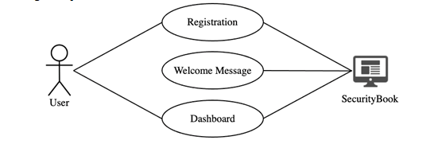

The users can also choose to log in to the app where they can use SSO login or SecurityBook login. Once the users are in, they receive a welcome message and continue to the dashboard.

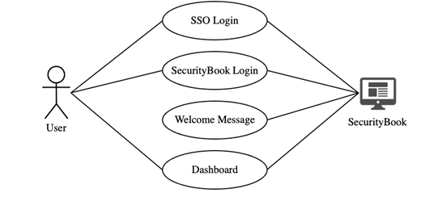

On the dashboard, the users see the posts of the people they follow, and from there they can like, comment, and share the content. There is a search bar that allows searching for other users by their name or a username, and posts by using a keyword. The users can follow anyone on the app as well as unfollow someone from their following list. On their main page, the users can share their pictures, videos as well as written posts. The app also allows its users to create groups or join an existing group where they can send messages as well as attach different files. Once the user is done using the app, he/she can exit at any moment by clicking on the Logout button.

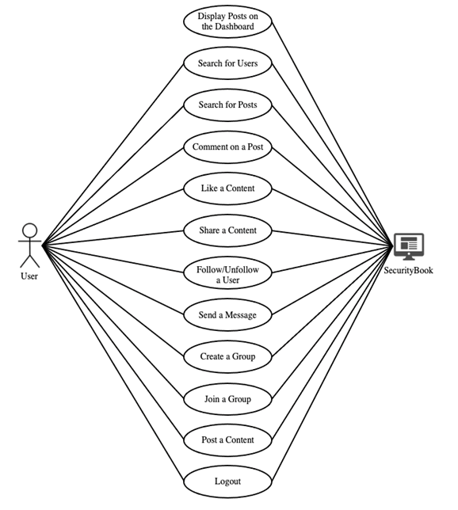

**5 Initial list of high-level functional requirements**

1. Create a user dashboard containing posts of other users they follow with their account. This is like an activity page, where posts of followed users will appear on the dashboard in a chronological fashion from the most recent post to the most dated post.
2. Users should be able to register and create unique accounts. Accounts will be unique to a user so that no two users have the same login information or registered email unless it is a guardian registering for a dependent.
3. Users will be able to search for other users with a search bar directing them to other registered users. If two users have the same name then the one that is closest in location or has mutual friends/followers will appear at the top.
4. Design a follow button that will connect users to one another and show their posts on each other’s dashboards.
5. Allow users to create and join unique groups. Groups can not be the same exact group but may have the same name.
6. Design a group ID to differentiate between two groups that may have the same name but for different reasons.
7. Design a “Groups” page showing the groups the user has joined, recommend groups to join that mutual followers/friends have joined as well.
8. Allow users to post videos, images, texts, and other forms of media. This will post to their own profile and their and their follower’s dashboards in chronological order.
9. Add an extra layer of encryption to protect user data from being stolen. (main feature)
10. Add multi factor authentication to prevent hacks and maintain authenticity of users. (main feature) i.e. Much like the way Duo Mobile works with FAU.
11. Design a friends/followers page or bar that allows users to go directly to pages of users they follow or groups they are in.
12. Add a messaging system that allows users to communicate with other users or their entire group.

**6 List of non-functional requirements**

1. The system will respond to user action within 1 second, and a user will wait no longer than one second for their action to register unless it is slowed down due to a fault.
2. The system will be easy to use for those without a background in technology. The common user who can access a website will be able to access the working site within 1 second of navigation to it and have the option to use SSO without issue until they decide to make an account.
3. The system will be available in all languages with an option to declare languages with the SSO account or the registered one. The system will also have instant-links that bring users to a specific group or personal page allowing them to connect without issue.
4. The system will be able to accommodate 10,000 users at a time without issue.
5. The system will not store any transactional data or website visits of the users as to maintain the main principle of SecurityBook. Login information will have to be stored and encrypted to protect the users secure information.
6. The system will be able to store login information of over 10,000 users without issue.
7. The system will be available whenever a user needs to use it unless the system is under a maintenance window at which point certain features or the whole system will be unusable until there is a fix, ideally a 3 hour window in which the fix(es) can be made.
8. The system will perform under minor faults at a slower speed, up to 2 times the original functional speed. Major faults may require maintenance.
9. The system will work identically on all OS types ( for example : Windows, Mac OS, and Linux) and on all common browsers ( for example : Google Chrome, Mozilla Firefox, and Safari)

**7 High-level system architecture**

Languages:

Front-End:

· HTML/CSS/Javascript

Back-end:

· PHP

· SQL

· Javascript? (Node.js)

Tools:

· MySQL

· phpMyAdmin

· Node.js?

· Heroku?

Libraries:

· jQuery?

Frameworks:

· Bootstrap 5

· React, Angular?

· Express?

**8 Team**

Bryan Perdomo – Product Owner

Adam Batat – Scrum Master

Mahri Almazova – Front-end Developer

Colton Johnson – GitHub Master

Ian Coston – Back-end Developer

**9 Checklist**

a) Team decided on basic means of communications - DONE

b) Team found a time slot to meet outside of the class - DONE

c) Front and back-end team leads chosen - DONE

d) GitHub master chosen - DONE

e) Team ready and able to use the chosen back and front-end frameworks

f) Skills of each team member defined and known to all - DONE

g) Team lead ensured that all team members read the final M1 and agree/understand it before submission - DONE